CDACL-006 Market Analysis
Submitted by Vishanth M S

Answers for the Tasks:
1. What are the top 10 aisles with the highest number of products?
Ans: SELECT
a.aisle_id,
a.aisle,
COUNT(p.product_id) AS product_count
FROM aisles a
JOIN products p
ON a.aisle_id = p.aisle_id
GROUP BY a.aisle_id, a.aisle
ORDER BY product_count DESC
LIMIT 10;
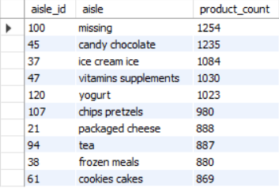
2. How many unique departments are there in the dataset?
Ans: SELECT COUNT(DISTINCT department_id) AS unique_departments
FROM departments;
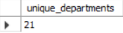
3. What is the distribution of products across departments?
Ans: SELECT
d.department_id,
d.department,
COUNT(p.product_id) AS product_count
FROM departments d
LEFT JOIN products p
ON d.department_id = p.department_id
GROUP BY d.department_id, d.department
ORDER BY product_count DESC;
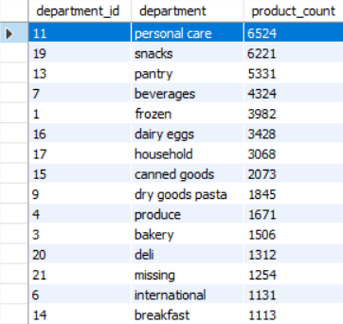
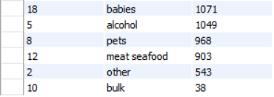
4. What are the top 10 products with the highest reorder rates?
Ans: SELECT
p.product_id,
p.product_name,
COUNT(*) AS total_orders,
SUM(op.reordered) AS reorder_count,
ROUND(
SUM(op.reordered) / COUNT(*) * 100,
2
) AS reorder_rate_percentage
FROM order_products_train op
JOIN products p
ON op.product_id = p.product_id
GROUP BY p.product_id, p.product_name
ORDER BY reorder_rate_percentage DESC
LIMIT 10;
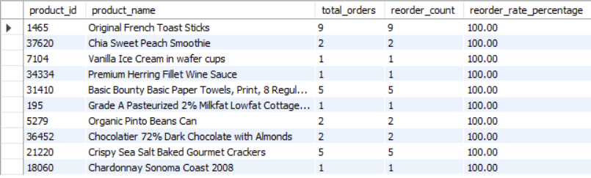
5. How many unique users have placed orders in the dataset?
Ans: SELECT COUNT(DISTINCT user_id) AS unique_users
FROM orders;
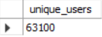

6. What is the average number of days between orders for each user?
Ans: SELECT
user_id,
ROUND(
AVG(days_since_prior_order),
2
) AS avg_days_between_orders
FROM orders
WHERE days_since_prior_order IS NOT NULL
GROUP BY user_id
ORDER BY avg_days_between_orders;

7. What are the peak hours of order placement during the day?
Ans: SELECT
order_hour_of_day AS hour,
COUNT(*) AS order_count
FROM orders
GROUP BY order_hour_of_day
ORDER BY order_count DESC;
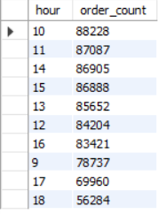

8. How does order volume vary by day of the week?
Ans: SELECT
CASE order_dow
WHEN 0 THEN 'Sunday'
WHEN 1 THEN 'Monday'
WHEN 2 THEN 'Tuesday'
WHEN 3 THEN 'Wednesday'
WHEN 4 THEN 'Thursday'
WHEN 5 THEN 'Friday'
WHEN 6 THEN 'Saturday'
END AS day_of_week,
COUNT(*) AS order_count
FROM orders
GROUP BY order_dow
ORDER BY order_dow;
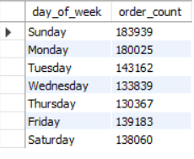

9. What are the top 10 most ordered products?
Ans: SELECT
p.product_id,
p.product_name,
COUNT(*) AS times_ordered
FROM order_products_train op
JOIN products p
ON op.product_id = p.product_id
GROUP BY p.product_id, p.product_name
ORDER BY times_ordered DESC
LIMIT 10;
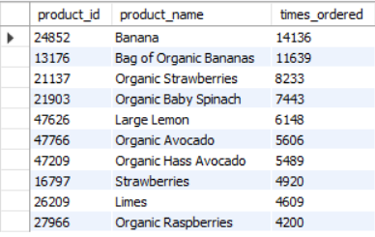

10. How many users have placed orders in each department?
Ans: SELECT
d.department_id,
d.department,
COUNT(DISTINCT o.user_id) AS unique_users
FROM orders o
JOIN order_products_train op
ON o.order_id = op.order_id
JOIN products p
ON op.product_id = p.product_id
JOIN departments d
ON p.department_id = d.department_id
GROUP BY d.department_id, d.department
ORDER BY unique_users DESC;
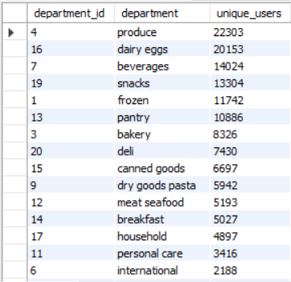
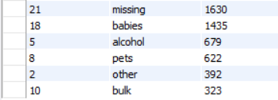

11. What is the average number of products per order?
Ans: SELECT
ROUND(AVG(product_count), 2) AS avg_products_per_order
FROM (
SELECT
order_id,
COUNT(product_id) AS product_count
FROM order_products_train
GROUP BY order_id
) AS order_sizes;
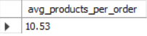

12. What are the most reordered products in each department?
Ans: SELECT
d.department,
p.product_id,
p.product_name,
SUM(op.reordered) AS reorder_count
FROM order_products_train op
JOIN products p
ON op.product_id = p.product_id
JOIN departments d
ON p.department_id = d.department_id
GROUP BY
d.department,
p.product_id,
p.product_name
ORDER BY
d.department,
reorder_count DESC;

13. How many products have been reordered more than once?
Ans: SELECT COUNT(*) AS products_reordered_more_than_once
FROM (
SELECT
product_id
FROM order_products_train
WHERE reordered = 1
GROUP BY product_id
HAVING SUM(reordered) > 1
) AS x;
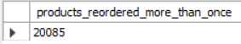

14. What is the average number of products added to the cart per order?
Ans: SELECT
ROUND(AVG(product_count), 2) AS avg_products_added_per_order
FROM (
SELECT
order_id,
COUNT(product_id) AS product_count
FROM order_products_train
GROUP BY order_id
) AS order_data;
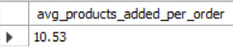

15. How does the number of orders vary by hour of the day?
Ans: SELECT
order_hour_of_day AS hour,
COUNT(*) AS order_count
FROM orders
GROUP BY order_hour_of_day
ORDER BY order_hour_of_day;
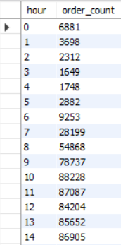
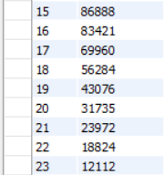

16. What is the distribution of order sizes (number of products per order)?
Ans: SELECT
product_count AS order_size,
COUNT(*) AS number_of_orders
FROM (
SELECT
order_id,
COUNT(product_id) AS product_count
FROM order_products_train
GROUP BY order_id
) AS order_sizes
GROUP BY product_count
ORDER BY product_count;

17. What is the average reorder rate for products in each aisle?
Ans: SELECT
a.aisle_id,
a.aisle,
ROUND(
AVG(op.reordered) * 100,
2
) AS avg_reorder_rate_percentage
FROM order_products_prior op
JOIN products p
ON op.product_id = p.product_id
JOIN aisles a
ON p.aisle_id = a.aisle_id
GROUP BY a.aisle_id, a.aisle
ORDER BY avg_reorder_rate_percentage DESC;

18. How does the average order size vary by day of the week?
Ans: SELECT
CASE o.order_dow
WHEN 0 THEN 'Sunday'
WHEN 1 THEN 'Monday'
WHEN 2 THEN 'Tuesday'
WHEN 3 THEN 'Wednesday'
WHEN 4 THEN 'Thursday'
WHEN 5 THEN 'Friday'
WHEN 6 THEN 'Saturday'
END AS day_of_week,

ROUND(
AVG(order_sizes.product_count),
2
) AS avg_order_size

FROM orders o

JOIN (
SELECT
order_id,
COUNT(product_id) AS product_count
FROM order_products_train
GROUP BY order_id
) AS order_sizes
ON o.order_id = order_sizes.order_id

GROUP BY o.order_dow
ORDER BY o.order_dow;
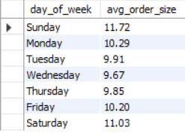

19. What are the top 10 users with the highest number of orders?
Ans: SELECT
user_id,
COUNT(order_id) AS total_orders
FROM orders
GROUP BY user_id
ORDER BY total_orders DESC
LIMIT 10;
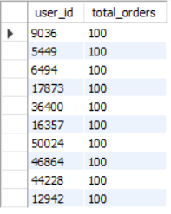

20. How many products belong to each aisle and department?
Ans: SELECT
d.department_id,
d.department,
a.aisle_id,
a.aisle,
COUNT(p.product_id) AS product_count
FROM products p
JOIN aisles a
ON p.aisle_id = a.aisle_id
JOIN departments d
ON p.department_id = d.department_id
GROUP BY
d.department_id,
d.department,
a.aisle_id,
a.aisle
ORDER BY
d.department,
product_count DESC;

Additional question : Analyze customer purchasing behavior and product performance to optimize marketing strategies and improve customer satisfaction.
Ans:
1. Customer purchase frequency
SELECT
user_id,
COUNT(order_id) AS total_orders
FROM orders
GROUP BY user_id
ORDER BY total_orders DESC;
insight:
Customers with a high number of orders can be classified as loyal/frequent customers.
Marketing strategy
- Loyalty rewards
- Personalized recommendations
- Subscription offers
- Early access to promotions
- Free delivery thresholds

2. Identify highly reordered products
SELECT
p.product_name,
SUM(op.reordered) AS reorder_count
FROM order_products_train op
JOIN products p
ON op.product_id = p.product_id
GROUP BY p.product_id, p.product_name
ORDER BY reorder_count DESC
LIMIT 20;
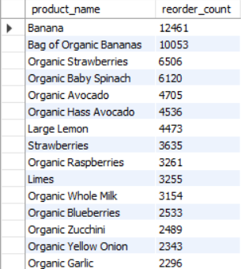
Business insight
Products with high reorder counts indicate strong customer loyalty and repeat demand.
Marketing strategy
Promote these products through:
- "Buy Again"
- Personalized recommendations
- Frequently Bought Together
- Subscription/reminder notifications

3. Identify peak shopping hours
SELECT
order_hour_of_day,
COUNT(*) AS orders
FROM orders
GROUP BY order_hour_of_day
ORDER BY orders DESC;
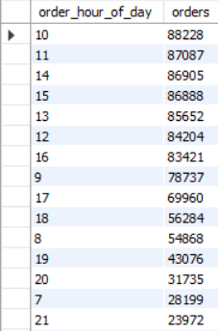
Business insight
The highest-order hours represent your peak customer activity.
Marketing strategy
Schedule:
- Flash sales
- Push notifications
- Personalized offers
- Limited-time discounts
around peak periods.
4. Identify popular departments
SELECT
d.department,
COUNT(*) AS products_ordered
FROM order_products_train op
JOIN products p
ON op.product_id = p.product_id
JOIN departments d
ON p.department_id = d.department_id
GROUP BY d.department_id, d.department
ORDER BY products_ordered DESC;
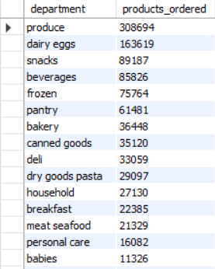
Business insight
High-volume departments represent categories with strong customer demand.
Marketing strategy
Increase:
- Promotions
- Product variety
- Inventory
- Cross-selling
in these departments.
5. Identify high-reorder aisles
SELECT
a.aisle,
ROUND(AVG(op.reordered) * 100, 2) AS reorder_rate
FROM order_products_prior op
JOIN products p
ON op.product_id = p.product_id
JOIN aisles a
ON p.aisle_id = a.aisle_id
GROUP BY a.aisle_id, a.aisle
ORDER BY reorder_rate DESC;
Business insight
Aisles with high reorder rates contain products customers frequently purchase again.
These are ideal for personalized recommendations.
6. Customer retention analysis
Use:
SELECT
order_number,
COUNT(DISTINCT user_id) AS users
FROM orders
GROUP BY order_number
ORDER BY order_number;
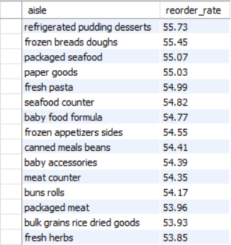
This helps understand how many customers continue ordering after their first purchase.
Business strategy
If the number of users drops significantly after the first or second order:
- First-order discount
- Second-order coupon
- Personalized recommendations
- Reminder emails
- Loyalty program
can improve retention.
Charts:
Products by Department:
